A soldier of the Great War.

Cecil Hamilton PARK was born in 1875 at Wareham, UK. His parents were Cecil Walgrave Park and Mary Park.

In 1895, at the age of 20 years, Cecil travelled to Ceylon (Sri Lanka) and worked in the tea industry.

In 1912 he emigrated to Australia from the UK with his wife Dolore Barbara, and 2 children, Maire and Cecil. They disembarked in Melbourne on 14 May 1912 having travelled on the SS Irishman.

In 1915 the family were living in Barkly Street Sunbury and Cecil was working as a farm labourer.
He enlisted in the AIF on 11/8/1915 and went into camp at the Melbourne Showgrounds. While returning to camp he was knocked down by a hansom cab as he alighted from a tram and his left leg was badly broken.He was discharged for the AIF on 31/7/1916 but reenlisted on 11/12/1916.

This time he was assigned to the 6th Battalion 24th Reinforcements and left Melbourne on 19/2/1917 aboard the HMAT Ballarat. His enlistment details were 7288.

The 24th Reinforcements for the 6th Battalion AIF were on their way to the battlefields of France and Belgium but the journey there was to encounter a major setback.

These men were among the 1752 troops and crew on board the HMAT Ballarat when she was sunk by a torpedo from a German submarine as she approached the southern English coast about 8 miles from The Lizard on 25 April 1917.

The troops and crew were all taken off by destroyers and drifters without loss of life.

Somewhere in this photo of the 6th Battalion 24th reinforcements would be Cecil , yet to be identified.

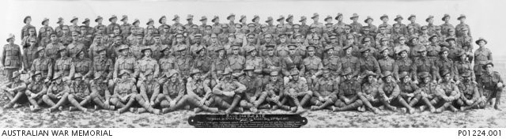

After training in the UK he was assigned to the 21st Battalion .His battalion war diary and records show him arriving in France on or around the 1st September 1917. His battalion would move to Ypres sector in Belgium.
He went into training at Campagne near Ypres and Dominion camp about 10kms SW for Ypres.

He finally was on the front lines and just 23 days later was badly wounded during the Third Battle of Ypres.

The Third Battle of Ypres is also known as the Battle of Passchendaele .The battle took place from July to November 1917, for control of the ridges south and east of the Belgian city of Ypres in West Flanders. Passchendaele was on the last ridge east of Ypres, 5 mi (8 km) from Roulers The station at Roulers was on the main supply route of the German army.

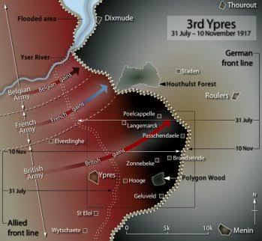

Cecil was be badly injured on 24/9/1917 in the vicinity of Bettawarde Ridge at Garter Point near Zonnebeke where the Battalion was in the front line. He was taken to the 6th Australian Field Ambulance clearing station. Later the 6th Field ambulance would transport the wounded back closer to Ypres. It appears that he was initially buried at Bettawarde Ridge (2 1/2 miles east of Ypres) where he was initially treated .
Ambulance clearing stations often had cemeteries attached for the dead.

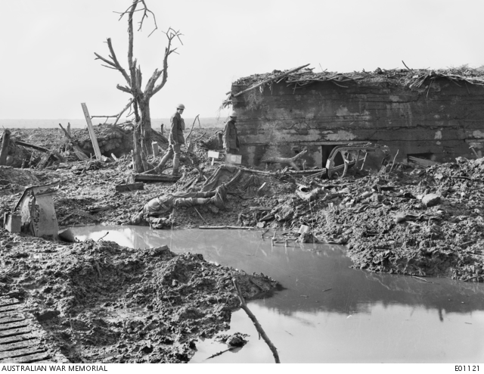
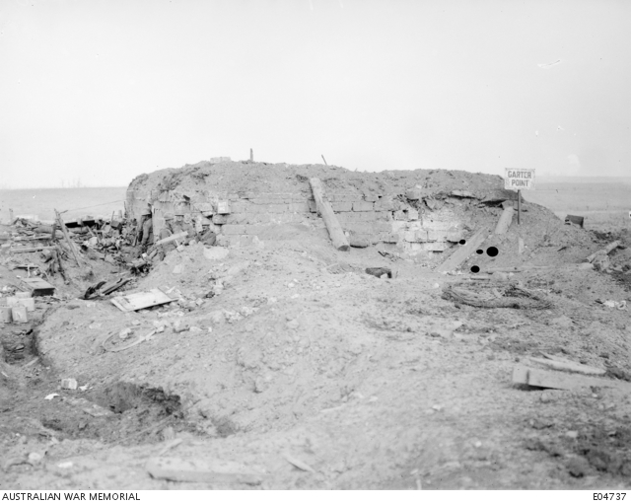
Garter Point near Zonnebeke.

His grave was lost due to the wet weather and constant bombardments and his body not recovered or identified at later times.He is now remembered on the Menin Gate Memorial at Ypres as a soldier with no known grave.

